Assignment 4: Reproducing Weakly Supervised Clustering by Exploiting Unique Class Count

Question

Generate results for MNIST dataset for ucc and clustering as in Table 1 in the paper.
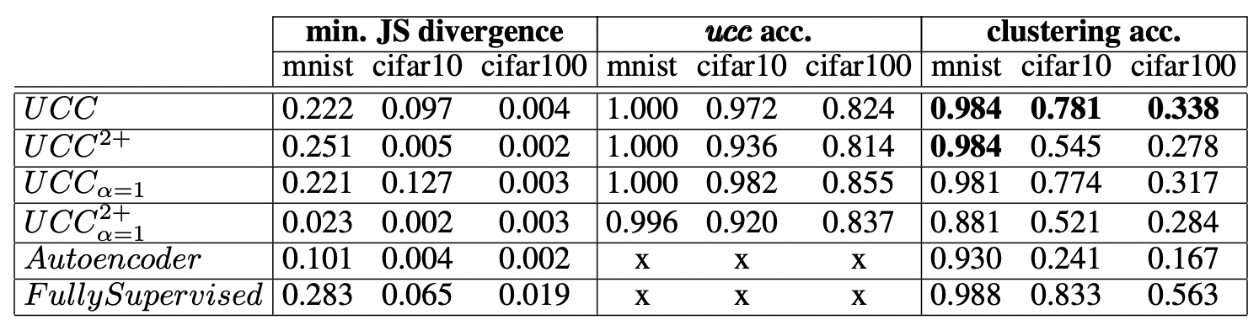
Plot all your results for analysis and explain them.

Try:
- Make different feature extractors and distribution regression
- Use full MNIST data set 60,000 for training, also use subset of MNIST for training and analyse the overfitting effects
  - 60,000 for training
  - 20,000 for training (same number of examples per class)
  - 5,000 for training (same number of examples per class)
  - 500 for training (same number of examples per class)
- Devise ways to improve this algorithm.

Answer

The code of this work and the trained models are available at
- http://bit.ly/uniqueclasscount and
- https://github.com/COMP6248-Reproducability-Challenge/UCC-Classifier/

The UCC models have several variants, depending on the weight α of two loss functions as shown below, and whether the autoencoder is included in the model. Below is the loss function where the left is the ucc loss calculated by the cross-entropy error, the right is the mean square error (MSE). By modifying the weights of cross-entropy and MSE errors, we can check the performance of each component of the model.
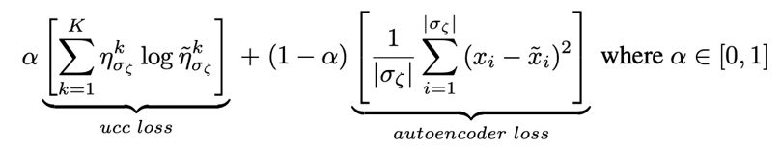

Model | AE loss  (Cross entropy) | UCC loss  (MSE) | Bag number
$$UCC$$ | Yes | Yes | 1-4
$${UCC}_{ }^{2+}$$ | Yes | Yes | 2-4
$${UCC}_{α=1}^{ }$$ | No | Yes | 1-4
$${UCC}_{α=1}^{2+}$$ | No | Yes | 2-4

Here we provided two versions of the code. One is taken from the original paper, while the other is from the a Github repo. To make the modifications shown above, we should modify the bag start number and the weight of loss functions in the code. I trained the models with 2000 epochs, which provides us with insights into the training difficulty and time cost. Below are my Colab Notebook links:

Model | Colab Notebook link
$$UCC$$ | https://colab.research.google.com/drive/1HZw5sFDCLuoSRaLAXMLUZhsey_Ob27mV?usp=sharing
$${UCC}_{ }^{2+}$$ | https://colab.research.google.com/drive/1DMiCXlVLzleUm8FL36gXqRdStjUHH8Y0?usp=sharing
$${UCC}_{α=1}^{ }$$ | https://colab.research.google.com/drive/1lkpv3ZN-2wRi2ZKp3SbYJ5YKW2lCZR20?usp=sharing
$${UCC}_{α=1}^{2+}$$ | https://colab.research.google.com/drive/1tzgYVpA2I2YeAD2rNPGa1X-RuhQJJwum?usp=sharing

Model | ucc  accuracy | Clustering accuracy
$$UCC$$ | 0.949 | 0.941
$${UCC}_{ }^{2+}$$ | 0.937 | 0.931
$${UCC}_{α=1}^{ }$$ | 0.960 | 0.947
$${UCC}_{α=1}^{2+}$$ | 0.931 | 0.899
In our experiments, no matter how large the dataset is, the training is similarly slow. It takes around 25-30 seconds to run each epoch. Reducing dataset size only slightly decreases the training time per epoch within the range. Thus, there is little possibility to run a full 60000 epochs as described in the paper, since Google Colab has 12-hour runtime limit.

Dataset size | ucc  accuracy
$$60000$$ | 0.949
$$20000$$ | 0.919
$$5000$$ | 0.864
$$500$$ | N/A
With the expansion of dataset, the generalisation ability of the model seems to increase as indicated by reduced loss values, yet the variance of the training loss increase with the epoch number and is larger in larger datasets, as indicated in the plots below and decreased validation accuracy. However, when the dataset size is only 500, the deep learning algorithm doesn’t converge, which produces no prediction results on test datasets.

Dataset size = 20000 | Dataset size = 5000
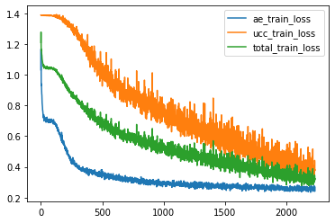 | 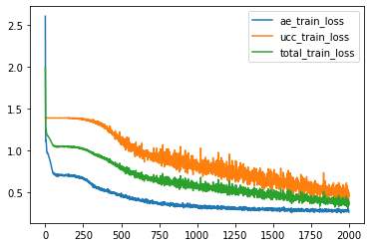

As for KDE, Appendix C.6 was added as per reviewers’ opinion. In the paper, a replacement of averaging layers was used to show the importance of KDE. Below is the result from the paper.
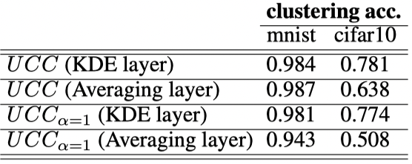
I tried different activation function here in the model structure. Below are the results. It seems that Sigmoid doesn’t provide good results for this model. ReLu is known to be more computational efficient than Sigmoid and is shown to have better convergence performance. So the results are not surprising, which confirms that ReLu serves the best interest of this paper.

 | ReLu | Sigmoid
$UCC$ ACCURACY | 0.949 | 0.641

Devise methods to improve the model

Firstly, according to the paper, the feature extractor and KDE parameters are determined according to model performance. The layer number of the convolutional architecture was determined as soon as the authors acquired good results.

Similarly, the kernel function of KDE could also be tuned, where there are a number of options that have not yet been tested, such as uniform, triangular, biweight, triweight, Epanechnikov, normal, and others. The original paper only shows that KDE is better than averaging but does not show that the current option is optimal.

Additionally, other layer structures could also be tested in future experiments for optimisation to include more optimal algorithms. As per our experiences in the last assignment, including data augmentation in the training may improve the training results.

https://github.com/COMP6248-Reproducability-Challenge/UCC-Classifier/tree/main/Reproducibility_Report
https://openreview.net/forum?id=B1xIj3VYvr
https://en.wikipedia.org/wiki/Kernel_density_estimation

